INQUIRY INTO THE TREATMENT OF INDIVIDUALS
SUSPECTED OF PEOPLE SMUGGLING OFFENCES WHO SAY THEY ARE CHILDREN

DISCUSSION PAPER: DECEMBER 2011

AUSTRALIAN HUMAN RIGHTS COMMISSION
CATHERINE BRANSON QC

SUBMISSION ON BEHALF OF:

DR. ANTHONY JOHN HILL.
PRESIDENT OF THE AUSTRALIAN SOCIETY OF FORENSIC ODONTOLOGY

CONTENTS
Summary page 3
Introduction page 5
Background page 5
Development of the human dentition page 6
Categories for age assessment page 6
Age assessment techniques page 6
Tooth Count and Eruption Chart comparisons page 7
Radiographic images and Atlas style comparisons page 7
OrthoPantomoGraphic (OPG) analysis page 7
Hand/Wrist radiographic interpretation page 9
Protocols and Standards for Age Assessment Examination page 10
Ethical Concerns page 10
Conclusion page 11
References page 12
Appendix I Medical Sciences Scientific Advisory Group Workshop page 14
Appendix II Schour and Massler Dental Development Atlas page 17
Appendix II Blenkin and Taylor Dental Development Atlas page 18
Appendix III Sakher J Al Qahtani Dental Development Atlas page 20
Appendix IV Clinical Report Template page 21
Appendix V Radiation Dosage Table page 23
List of Figures
Figure 1 OrthoPantomoGraph Age 16 years page 8
Figure 2 OrthoPantomoGraph Age 18 years page 8
Figure 3 OrthoPantomoGraph Age 20 years page 9
Figure 4 Skeletal Development Child aged 6 years page 9
Figure 6 Skeletal Development Child aged 11 years page 9

SUMMARY
An age estimate is the chronological age range of an individual determined from the analysis of dental, skeletal and other physical characteristics, compared to relevant standards developed from individuals of known age. Precise determination of age is not possible due to human variation; an age range, with confidence intervals is the best expression of age estimation.
If age estimation is limited to an external physical examination and reliance upon circumstantial evidence derived from interviews with parents, guardians, school authorities or public documents sourced from the individual’s home, there is a potential for gross error in either over or under estimating the age.
A multi-factorial approach, where examination of multiple age markers in the same individual is undertaken, will result in a more accurate age estimate than if one age marker only is assessed. It is recognised that dental development is able to provide the most reliable indicator for chronological age from birth until 15 years of age.
Observation of the number and type of teeth present in the oral cavity, by simple intra-oral and x-ray examination, can be used to estimate the age of an individual between birth and 15 years. Since this technique is non-invasive, safe, child and gender sensitive it would be a technique of choice for determination of the age of an individual still in the process of exfoliating deciduous. The age assessment is simplistic in nature, can be expediently undertaken, will rapidly assist in the direction of legal proceedings and will allow for the expedient return of the child to his/her legal guardian if the individual is determined to be a child.
The analysis of third molar (wisdom tooth) development, from an OrthoPantomoGraphic (OPG) image assessment, is sufficiently correlated with chronological age to be of forensic value. The assessment of the development of the third molar provides an ideal means to discriminate between an adult and a child. Third molars develop from mid-teens to early 20s and complete closure of the apices of the third molar teeth is an indication that the living individual is over the age of 18 years and thus, by definition, an adult.
Hand/Wrist X-ray examination was designed as a tool to assess the general skeletal development and overall growth of an individual. The Greulich-Pyle Radiographic Atlas (GPRA) consists of a series of standard, skeletal hand/wrist x-rays which relate to a range of known chronological ages. It is this atlas that is used in Australia for age assessments. At no time was this atlas designed to determine chronological age; it was designed as a tool for health workers to better assess a child’s skeletal development and overall growth.
Protocols and standards for age assessment examination have been agreed upon by the Australian Society of Forensic Odontology:
- Signed, written informed consent must be obtained from the client or his/her legal representative, before any examination is undertaken. The informed consent must clearly explain to the client, that the examination is primarily to assess the age of the client. However, since the examination would encompass a general health screening, any abnormal medical, hard tissue or bony pathology noted would be included in the written report.
- An intra-oral examination of the detainee shall be undertaken in a suitably equipped dental operatory by a fully trained and experienced forensic odontologist.
- An OPG and/or hand/wrist radiograph shall be taken of the detainee by a qualified and registered radiographer.
- A panel of qualified, registered and experienced practitioners, chaired by a forensic odontologist, (including anthropologists, radiographers, pediatricians, or orthodontists), shall assess all information gathered.
- A clinical report shall be written covering all aspects of the general oral condition, including hard and soft tissue anomalies that may be found.
- An age assessment of the client shall be given which will include an age range.
All States and Territories within Australia have qualified and experienced forensic odontologists within easy reach of centres where those suspected or accused of people smuggling, who claim to be children (under 18), are detained. All centres have suitable medical facilities in which oral examinations can be undertaken and many have radiographic facilities which can produce appropriate x-ray images. In some cases the detainee may have to be transferred to an outside radiography facility to obtain an OPG and/or hand/wrist radiograph. It is anticipated that the time taken from an initial examination to the presentation of a final signed medico-legal report, including the age estimation would be 14 days. This clearly sits within the timeframe proposed in the Amendments to the CRIMES AMENDMENT (FAIRNESS FOR MINORS) BILL 2011 (Senator Hanson-Young), Item 3, No 8 .
Since any age estimate would be reported as an age range, it allows a Magistrate to interpret the age estimate results on the ‘balance of probabilities’. This then gives the detainee the right to the rule of ‘the benefit of the doubt’ and addresses concerns rested in the Convention of the Rights of the Child (CRC).
There needs to be considered debate concerning the risks and ethics associated with the use of X-rays for non-medical purposes versus the benefits of more accurate age assessments in the interests of justice.

Introduction
I make this submission to the Inquiry in my capacity as President of the Australian Society of Forensic Odontology (AuSFO) and Consultant Forensic Odontologist to the Victorian Institute of Forensic Medicine (VIFM). The VIFM is a statutory authority incorporated under the Victorian Institute of Forensic Medicine Act 1995 and operates under the auspices of the Department of Justice, reporting to the Parliament through the Attorney-General. Part of the statutory responsibilities of the VIFM is to provide independent, expert and credible forensic medical and scientific services to the justice system.

This submission seeks to address the following terms of reference for the Inquiry:
- assessments of the ages of the individuals of concern made by or on behalf of the Commonwealth for immigration purposes, including by any ‘officer’ as defined by section 5 of the Migration Act 1958 (Cth);
- assessments of the ages of the individuals of concern during the course of the investigations of the people smuggling or related offences of which they were suspected;
- assessments of the ages of the individuals of concern for the purpose of decisions concerning the prosecution of the people smuggling or related offences of which they were suspected;
- the preparation for and the conduct of legal proceedings in which evidence concerning the ages of the individuals of concern was, or was intended to be, adduced;
- any other matters incidental to the above terms of reference.
Background
The ability to assign an accurate age to living individuals charged with people smuggling offences has become a matter of urgency following recent well-publicised cases in New South Wales, Queensland and Victoria where children have spent long periods of time incarcerated in adult correctional facilities. The Commission is aware of a number of cases where individuals suspected of people smuggling offences were acknowledged to be children after they had spent long periods of time in adult correctional facilities. It has been reported, as of 17th October 2011, there are around 25 people in either immigration detention or remand facilities charged with people smuggling offences, who say they are children. There are a further seven people in immigration detention who say they are children and have yet to be charged. These figures do not include people who were assumed to be adults in court proceedings, were subsequently convicted and imprisoned, but who continue to say they are children [1].
In 1990, Australia ratified the Convention on the Rights of the Child (CRC) the key human rights treaty regarding children. The imprisonment of a child in an adult prison is a direct breach of the following rights as stipulated under the CRC:
- The right to be treated in a manner which takes into account a child’s age and the desirability of promoting the child’s reintegration (article 40(1)).
- The right to be arrested detained or imprisoned only as a measure of last resort and for the shortest appropriate period of time (article 37(b)).
- The right to be protected from all forms of physical or mental violence, injury or abuse, neglect or negligent treatment, maltreatment or exploitation including sexual abuse, while in the care of parents, legal guardians or any other person who has the care of the child (article 19).
There are a range of other rights, outlined in the Discussion Paper, which may also be breached as a result of incarceration of a child, in an adult facility, following an inadequate process of age assessment [1].
It is therefore of the utmost importance that scientifically tested and proven techniques are utilised if accurate and meaningful age estimations are to be given. The simple expediency of visual assessment of a living individual, documentary and circumstantial evidence obtained following interview with parents, guardians or public authorities sourced from the individual’s home country, opens the possibility for manipulation and falsification of such evidence. The evidence of untrained, inexperienced persons involved in the confinement of detainees is also unsound. Age assessment must be undertaken using scientific, research supported evidence and techniques grounded in well recognised, robust, academic foundations. This must involve a multi-factorial approach where examination of multiple age markers from the same individual is undertaken. Most authorities are agreed that data derived from the developing dentition provides the most accurate means of age estimation. This fact, coupled with the high survivability of teeth exposed to severe physical factors, makes assessment of the developing teeth the method of choice in forensic age estimation [2-7].
Development of the human dentition
The sequential, predictable, chronological pattern of exfoliation and eruption of the human dentition, as living individuals progress from infancy to adulthood, has long been used as a means to assess the probable age of that individual. To better understand the scientific basis for the use of this technique, there is a need to briefly understand the process of exfoliation and eruption.
The development of the human dentition begins in utero, with the first primary (deciduous) tooth appearing in the oral cavity at around 6 months of age. The primary dentition then develops in a well-documented sequence and is complete by 3 years of age. The appearance of the first permanent molar tooth at around 6 years of age signifies a period of loss of all deciduous teeth and replacement with their permanent successors. The process of eruption of the permanent teeth and associated exfoliation of primary teeth occurs in a sequential, predictable pattern and is complete at around 15 years of age. The final permanent tooth to erupt into the oral cavity is the third permanent molar, commonly referred to as the wisdom tooth. This tooth is radiographically visible at 10 years of age with development completed by the early 20’s. Once dental development and eruption is complete, the adult dentition changes as a result of occlusal attrition, restorative procedures and tooth loss [8-14).
Categories for age assessment
In May 2010, under the auspices of Australia and New Zealand Police Advisory Agency/National Institute of Forensic Science, the Medical Sciences Scientific Advisory Group convened a workshop meeting in Adelaide entitled ‘A Critical Assessment of Human Age at Death Estimations’ [Appendix I]. This was attended by Australian forensic odontologists and forensic anthropologists. One of the agreed outcomes of the workshop was the defining of categories for age assessments as being:
- Foetal 8weeks – birth
- Infant 0 – <2 years
- Child 2 - <13 years
- Adolescent 13 -<18 years
- Adult >18+ years
This classification is in accord with the Conventions on the Rights of the Child (CRC) definition of a child, as being an individual under 18 years of age.
Age assessment techniques
Historically, non-invasive techniques for age assessment of living individuals include direct intra-oral examination and the utilization of various medical imaging modalities. Conventional X-ray and Computer Tomography (CT) scanning techniques capture images of the developing skeleton and dentition. The anatomical sites most commonly radiographed are the hand/wrist region for assessment of skeletal development, the maxillary and mandibular dentition for assessment of dental development and more recently the use of CT scanning techniques to capture images of both the developing clavicle and the dentition [15-17].
It is recognised that dental development is able to provide the most reliable indicator for chronological age from birth until 15 years of age. This is due to the fact that tooth formation (maturation) develops independent of somatic, skeletal and sexual maturation. Dental development is also less affected by environmental insults and systemic illness [18-24].
- Tooth Count and Eruption Chart Comparisons:
Observation of the number and type of teeth present in the oral cavity is widely used as a means of age assessment. This technique is based on the assumption that the process of eruption of the permanent teeth and associated exfoliation of primary teeth occurs in a sequential, chronologically ordered pattern and is complete at around 15 years of age. By observing which teeth are present in the oral cavity and referring to established scientific eruption charts or pictorial representations of the eruption patterns, one can estimate the dental age of an individual. Since this technique is non-invasive, safe, child and gender sensitive it would be a technique of choice for estimation of the age of an individual still in the process of exfoliating deciduous teeth and in the final stages of eruption of the second permanent molars – ages 10-15 years [25]. The age assessment is simplistic in nature, can be expediently undertaken, will rapidly assist in the direction of legal proceedings and will allow for the expedient return of the child to his legal guardian. Concerns that may have rested in the Convention of the Rights of the Child (CRC) will also have been addressed.
- Radiographic Images and Atlas Style Comparisons:
The dental development atlas shows a diagrammatic, pictorial representation of the development of the dentition from birth to 35 years of age. The most regularly cited atlas depicting the stages of dental development is that of Schour and Massler [Appendix II]. However more recent versions, Blenkin and Taylor [Appendix III] and Al Qahtani [Appendix IV] are now commonly referenced. The technique used for age assessment involves the comparison of an OrthoPantomoGraph (OPG) radiographic image of the maxillary and mandibular teeth with the atlas diagrammatic representation of the stage of development of the human dentition at a given age. By matching the radiographic image to a specific atlas diagram the estimated age of the child is assigned. Whilst the earlier atlas style representation (Schour/Massler; J Al Qahtani) were not derived from Australian specific data, the results proved to be of sufficient accuracy and relevance that they were commonly used in dental practise for timing of interventionist treatment. The atlas of Blenkin and Taylor has been derived from contemporaneous data obtained from a cohort of Australian individuals and would be the reference of choice. Due to lack of specific data, no atlas has been compiled for an Indonesian population. However, it can be seen from the three referenced atlas’ used, there is general accord between the various pictorial representations relating to a specific age. Since any age assessment based on the atlas comparison would be reported as an age range, it allows a Magistrate to interpret the age assessment results on the ‘balance of probabilities’. This then gives the child the right to the rule of the ‘benefit of the doubt’ and again addresses concerns rested in the Convention of the Rights of the Child (CRC). Since this technique involves the use of x-ray images, there are ethical issues that need to be addressed. This would be the technique of choice for age assessment of individuals who, on intra-oral examination, show evidence of no deciduous (primary) teeth.
- OrthoPantomoGraphic (OPG) Analysis – development of the third molar (wisdom tooth)
Recent research has concentrated on the use of third molar (wisdom tooth) development in age assessment. These studies have found analysis of third molar development to be accurate and sufficiently correlated with chronological age to be of forensic value [26-33] At the time of the development of the third molars, from mid-teens to early 20s, there are few reliable dental methods of age estimation other than to analyse the calcification and root development of the third molars [Figs 1-3]. Third molar statistics are often presented as evidence of the likelihood that the individual has attained an age of 18 years (complete closure of the apex of the root), or as a percentage of the population who would be aged 18 years when the third molar had completed development. This method of age assessment, of necessity, involves the capture of radiographic images of the third molars as they lie within the mandible and maxilla and ethical issues need to be addressed before images are captured. Many detention centres housing refugees do have radiography facilities which can produce suitable intra-oral images, but in most cases detainees would have to be transported to an outside centre to obtain appropriate OPG radiographs. The assessment of the radiograph would need to be undertaken by a panel of specialists experienced in the interpretation of both the OPG and dental development.
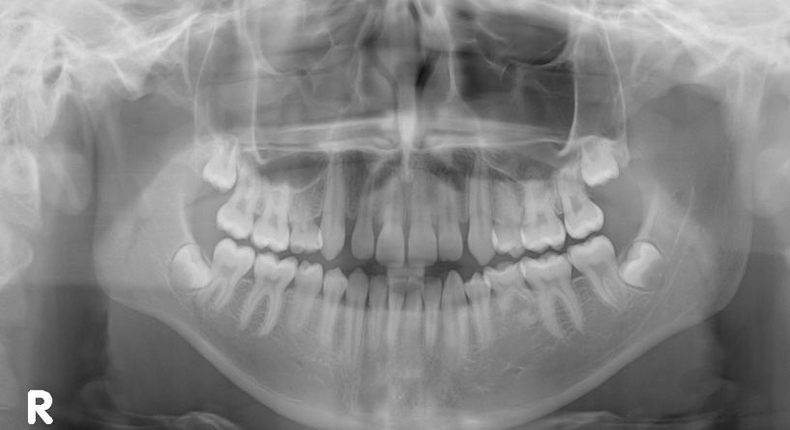
Third molar – crown only formed
Fig 1
OrthoPantomoGraph Age 16 years – Third molar unerupted; Crown only formed.

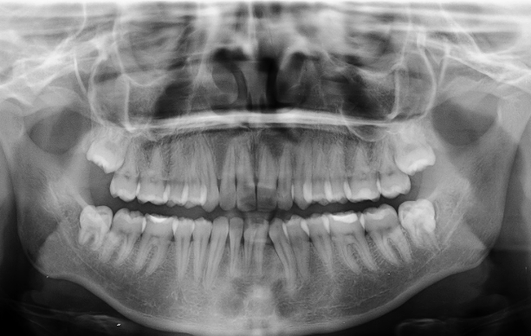
Third molar – crown formed; root apices open

Fig 2
OrthoPantomoGraph Age 18 years – Third molar Impacted; Crown fully developed; Root apices open.

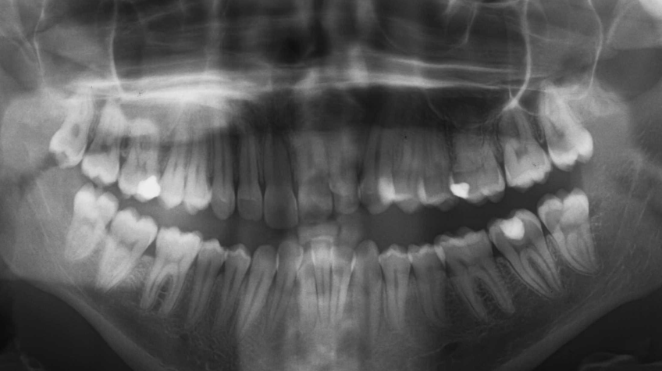
Third molar erupted; root apices closed
Fig 3
OrthoPantomoGraph Age 20 years – Third molars fully erupted; Apices closed.
The assessment of the development of the third molar provides an ideal means to discriminate between an adult and a child. Recent studies have shown that complete closure of the apices of the third molar tooth is an indication that the living individual is over the age of 18 years and thus, by definition, an adult [34-36].
- Hand/Wrist radiographic interpretation
Hand/Wrist X-ray examination was designed as a tool to assess the general skeletal development and overall growth of children. The reference sample used was a selection of 1000 middle-class American children who were born the 1930’s-1940’s, aged from birth to nineteen years of age The data was used to develop the Greulich-Pyle Radiographic Atlas (GPRA) and consists of a series of standard, skeletal hand-wrist x-rays which relate to known chronological ages. The atlas displays skeletal development at three-month intervals during the first year of life; six-month intervals from one to five years; and one year intervals thereafter; up to 19 years. It is this atlas that is used in Australia for age estimations.

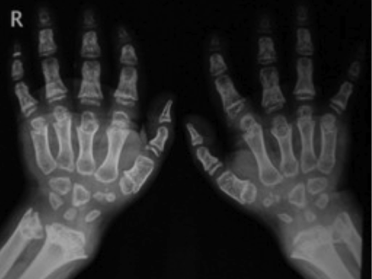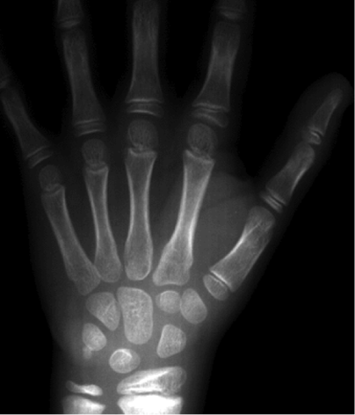
Fig 4 Fig 5
Skeletal Development Child aged 6 years Skeletal Development Child aged 11 years

At no time was this atlas designed to determine chronological age; it was designed as a tool for health workers to better assess a child’s skeletal development and overall growth. Clearly, the major drawback when using this technique for age assessment is that images included in the atlas were obtained some 60 years ago from individuals who grew up on the other side of the world, under environmental conditions totally different to the refugees being assessed. Biological variation in human development means that any age assessment based on GPRA analysis of growth markers will inevitably contain a degree of error.
Recent research has focused on the development of various multi-factorial approaches to age estimation. A multi-factorial system involves using a combination of developing anatomical features in concert in order to arrive at an estimate which will offer increased accuracy and precision over an estimate which uses development sites individually [37-40]. In order to gain the most complete picture regarding an individual’s developmental status it is apparent that both dental and skeletal age markers need to be examined together. Research has also suggested that CT imaging and analysis of the skeletal development of the clavicle (collar bone), which has a far longer development time than the wrist, could be used to assess age well into the 20s.
Current thinking would suggest that age estimation is best practiced as a multi-disciplinary specialty, in that practitioners engaged should be familiar with the theory and practice of forensic anthropology, forensic odontology, medical imaging, human growth and development, and anatomy. To obtain the most accurate age estimates, it is evident that practitioners from different disciplines need to work together and reports should be written following consultation from a panel of experts who have examined all relevant data. This would maximise the accuracy of age estimations.
Protocols and Standards for Age Assessment Examination
- Signed, written informed consent must be obtained from the client, or his/her legal representative, before any examination is undertaken. The informed consent must clearly explain to the client, that the examination is primarily to assess the age of the client. However, since the examination would encompass a general health screening, any abnormal medical, hard and soft tissue pathology noted would be included in the written report.
- A complete intra-oral examination of the detainee shall be undertaken in a suitably equipped dental operatory by a fully trained and experienced forensic odontologist.
- A hand/wrist and/or OPG radiograph radiographs shall be taken of the detainee by a qualified and registered radiographer.
- A panel of qualified, registered and experienced practitioners, chaired by a forensic odontologist, and including anthropologists, radiographers, pediatricians, or orthodontists, shall assess all information gathered.
- A clinical report shall be written covering all aspects of the general oral condition, including hard and soft tissue anomalies that may be found.
- An age estimate report of the detainee shall be given which will include an age range (Appendix V).
It should be noted that all States and Territories within Australia have qualified and experienced forensic odontologists within easy reach of all detention centres housing suspected child refugees. All detention centres have suitable medical facilities in which oral examinations can be undertaken and many have radiographic facilities which can produce appropriate x-ray images. In some cases the detainee may have to be transferred to an outside radiography facility to obtain an OPG and/or hand/wrist radiograph. It is anticipated that the time taken from initial examination to the presentation of a final signed medico-legal report, including the age estimation, would be completed within 14 days. This clearly sits within the timeframe proposed by the recently proposed Amendments to the CRIMES AMENDMENT (FAIRNESS FOR MINORS) BILL 2011 (Senator Hanson-Young), Item 3, No 8 [41] and fulfils article 37(b) of the CRC (‘imprisoned….for the shortest appropriate period of time’).
Ethical Concerns
There are medico-ethical and legal considerations involved in conducting radiological procedures – with no defined medical need – on living people. Whilst the process of taking radiographic images of the development of the dentition or imaging hand/wrist areas for general skeletal development could be considered part of an overall health screening procedure, the ultimate reason for the radiographs being undertaken is to assess the age of the individual. In any investigation specifically focused on an age assessment, the detainee must be fully informed of the reasons and written ‘informed consent’ must be obtained before any investigation is undertaken.
Comprehensive age assessment of living individuals necessarily involves the use of ionising radiation (X-rays). Radiation of the hand/wrist region or the taking of OPG radiographs involves unavoidable radiation exposure. CT imaging of the head and neck area or the clavicular region also involves unavoidable radiation exposure. Whilst this exposure is not at a level sufficient to cause immediate harm, it does raise the total lifetime dose of radiation experienced by the individual (Appendix VI).
These issues have yet to be addressed by the government.
Conclusion
An age estimate is the chronological age range of an individual determined from the analysis of dental, skeletal and other physical characteristics, compared to relevant standards developed from individuals of known age. Precise determination of age is not possible due to human variation; an age range, with confidence intervals is the best expression of age estimation
The simple expediency of visual assessment of a living individual, documentary and circumstantial evidence obtained following interview with parents, guardians or public authorities sourced from the individual’s home country, opens the possibility for manipulation and falsification of such evidence. There is also potential for gross error in either over or under estimating the age.
In order to gain the most complete picture regarding an individual’s developmental status it is apparent that both dental and skeletal age markers need to be examined together. A multi-factorial approach, where examination of multiple age markers in the same individual is undertaken, will result in a more accurate age estimate than reliance upon only one age marker.
It is recognised that dental development, as opposed to skeletal development, is able to provide the most reliable indicator for chronological age from birth until 15 years of age.
Studies have found that analysis of third molar development is accurate and sufficiently correlated with chronological age to be of forensic value. Third molars develop from mid-teens to early 20s and complete closure of the apices of the third molar teeth is an indication that the living individual is over the age of 18 years and thus, by definition, an adult.
A panel of qualified and experienced practitioners, chaired by a forensic odontologist, and including anthropologists, radiographers, paediatricians, or orthodontists, should assess all information gathered. Forensic age estimation is no longer simply a matter of specialists restricting themselves to their own traditional fields but is a specialty that requires expertise in multiple fields of endeavour.
Age assessment will be given which includes an age range of the detainee. This will allow a Magistrate to interpret the age assessment results on the ‘balance of probabilities’ and give the detainee the right to the rule of the ‘benefit of the doubt’. It also addresses concerns rested in the Covention of the Rights of the Child (CRC).
The proposed protocols and standards for age estimation meet UNHCR criteria for age assessments guidance for refugee and migrant children:
- be comprehensive, taking into account both physical appearance and psychological maturity
- be conducted in a safe, child and gender sensitive manner
- allow margins of error or caution when scientific procedures are used
- provide children with the benefit of the doubt in cases of uncertainty
- give children clear information about the purpose and process of assessment procedures in a language they understand
- appoint a qualified, independent guardian to advise the child prior to an assessment procedure
There needs to be a considered debate about the risks and ethics associated with the use of X-rays for non-medical purposes versus the benefits of more accurate age assessments in the interests of justice.
REFERENCES

- Australian Human Rights Commission; Inquiry into the treatment of individuals suspected of people smuggling offences who say they are children; Discussion paper: December 2011
- Bedford ME, Russell KF, Lovejoy CO, Meindl RS, Simpson SW, Stuart-Macadam PL. Test of the multifactorial aging method using skeletons with known ages-at-death from the grant collection. Am J Phys Anthro. 1993;91(3):287–97.
- Garamendi PM, Landa MI, Ballesteros J, Solano MA. Reliability of the methods applied to assess age minority in living subjects around 18 years old. A survey on a Moroccan origin population. Forensic Sci Int. 2005;154(1):3–12.
- Bhat VJ, Kamath GP. Age estimation from root development of mandibular third molars in comparison with skeletal age of wrist joint. Am J Forensic Med Pathol. 2007;28(3):238–41.
- Martrille L, Ubelaker DH, Cattaneo C, Seguret F, Tremblay M, Baccino E. Comparison of four skeletal methods for the estimation of age at death on white and black adults. J Forensic Sci. 2007;52(2):302–7.
- Franklin D. Forensic age estimation in human skeletal remains :current concepts and future directions. Leg Med (Tokyo). 2010;12(1):1–7.
- Bassed RB, Briggs C, Drummer OH. Age estimation using the third molar tooth, the medial clavicular epiphysis, and the spheno-occipital synchondrosis: a multifactorial approach. Forensic Sci Int. 2011; doi:10.1016/j.for-sciint.2011.06.007.
- AlQahtani, S., Hector, M and Liversidge, H 2010. Brief Communication: The London atlas of human tooth development and eruption. American journal of Physical Anthropology, 142:481-490.
- Schour, I. and Massler, M. (1940) Studies in tooth development: The growth pattern of human teeth, Part II. J Am Dent Assoc, 27, 1918-1931
- Ciapparelli, L. The chronology of dental development and age assessment. In: Practical Forensic Odontology (ed Derek H Clark), Wright Oxford OX2 8DP, pp. 22 -42.
- Logan, W.H.G. and Kronfeld, R. (1933) Development of the human jaws and surrounding structures from birth to the age of fifteen years. J Am Dent Assoc, 20, 379-427
- Moorrees, C.F.A., Fanning, E.A, and Hunt, E.E. (1963) Age variation of formation stages for ten permanent teeth. J Dent Res, 42,1490-1502
- Demirjian A, Goldstein H, Tanner JM. A new system of dental age assessment. Hum Biol. 1973;45(2):211–27.
- Webb PA, Suchey JM. Epiphyseal union of the anterior iliac crest and medial clavicle in a modern multiracial sample of American males and females. Am J Phys Anthropol. 1985;68(4):457–66.
- Bassed RB, Hill AJ. The use of computed tomography (CT) to estimate age in the 2009 Victorian bushfire victims: a case report. Forensic Sci Int. 2011;205(1–3):48–51.
- Schulz R, Muhler M, Mutze S, Schmidt S, Reisinger W, Schmeling A. Studies on the time frame for ossification of the medial epiphysis of the clavicle as revealed by CT scans. Int J Legal Med. 2005;119(3):142–5.
- Lewis AB, Garn SM. The relationship between tooth formation and other maturational factors. Angle Orthod. 1960;30:70–7.
- Smith BH. Standards of human tooth formation and dental age assessment. In: Kelley ML, Larsen CS, editors. Advances in dental anthropology. New York: Wiley-Liss, Inc; 1991. p. 143–68.
- Gustafson, G. and Koch, G. (1974) Age estimation up to 16 years of age based on dental development. Odont. Revy, 25, 297-306
- Smith, B.H. (1991) Standards of human tooth formation and dental age assessment in dental age assessment.I In: Advances in Dental Anthropology (eds M.A. Kelly and C.S. Larsen), Wiley-Liss Inc, New York, pp. 143-168
- Lewis, A.B. and Garn, S.M. (1960) The relationship between tooth development and other maturational factors. Angle Orthod, 30,70-77
- Demirjian, A., Buschang, P.H., Tanguay, R. and Kingnorth-Patterson, D. (1985) Interrelationships among measures of somatic, skeletal, dental, and sexual maturity. Am J Orthod, 88, 433-438
- Holtgrave, E.A., Kretschmer, R. and Muller, R. (1997) Acceleration in dental development: fact or fiction. Eur J Orthod, 19, 703-710
- Taylor JA, Blenkin MRB. (2010). Age Evaluation and Odontology. In Black, Aggrawal and Payne-James (eds) Age Estimation in the Living: Theory and practice for the Medico-Legal Professions. Wiley
25 Engström, C., Engström, H. and Sagne, S. (1983) Lower third molar development in relation to skeletal maturity and chronological age. Angle Orthod, 53, 97-106
26Mincer. H.H., Harris, E.F. and Berryman, H.E. (1993) The ABFO study of third molar development and its use as an estimator of chronological age. J Forensic Sci, 38,379-390
27 Mesotten, K., Gunst, K., Carbonez, A. and Willems, G. (2002) Dental age estimation and third molars: a preliminary study. Forensic Sci Int, 26, 110-115
- Bhat, V.J. and Kamath, G.P. (2007) Age estimation from root development of mandibular third molars in comparison with skeletal age of wrist joint. Am J Forensic Med Pathol, 28, 238-241
- Martin-de las Heras, S., Garcia-Fortea, P., Ortega, A., Zodocovich, S. and Valenzuela, A. (2008) Third molar development according to chronological age in populations from Spanish and Magrebian origin. Forensic Sci Int, 174, 47-53
- Meinl, A., Tangl, S., Huber, C., Maurer, B. and Watzek, G. (2007a) The chronology of third molar mineralization in the Austrian population – a contribution to forensic age estimation. Forensic Sci Int, 169, 161-167
- Gunst, K., Mesotten, K., Carbonez, A. and Willems, G. (2003) Third molar development in relation to chronological age: a large sample sized retrospective study. Forensic Sci Int, 136, 52-57
- De Salvia, A., Calzettac C., Orrico, M. and De Leo, D. (2004) Third mandibular molar radiological development as an indicator of chronological age in a European population. Forensic Sci Int, 146S, S9-S12.
- Olze, A., van Niekerk, P., Schulz, R. and Schmeling, A. (2007) Studies of the chronological course of wisdom tooth eruption in a Black African population. J Forensic Sci, 52, 1161-1163
- Mincer. H.H., Harris, E.F. and Berryman, H.E. (1993) The ABFO study of third molar development and its use as an estimator of chronological age. J Forensic Sci, 38,379-390
- Bassed, R. B., C. Briggs, et al. "Age estimation and the developing third molar tooth: an analysis of an Australian population using computed tomography." J Forensic Sci 56(5): 1185-1191
- Meinl, A., Tangl, S., Huber, C., Maurer, B. and Watzek, G. (2007a) The chronology of third molar mineralization in the Austrian population – a contribution to forensic age estimation. Forensic Sci Int, 169, 161-167
- Garamendi PM, Landa MI, Ballesteros J, Solano MA. Reliabilityof the methods applied to assess age minority in living subjects around 18 years old. A survey on a Moroccan origin population. Forensic Sci Int. 2005;154(1):3–12.
- Bhat VJ, Kamath GP. Age estimation from root development ofmandibular third molars in comparison with skeletal age of wristjoint. Am J Forensic Med Pathol. 2007;28(3):238–41.
- Martrille L, Ubelaker DH, Cattaneo C, Seguret F, Tremblay M,Baccino E. Comparison of four skeletal methods for the estimation of age at death on white and black adults. J Forensic Sci.2007;52(2):302–7.
- Franklin D. Forensic age estimation in human skeletal remains:current concepts and future directions. Leg Med (Tokyo).2010;12(1):1–7.
- The Parliament of the Commonwealth of Australia. The Senate. Crimes Amendment (Fairness for Minors) Bill 2011; No 2011. A Bill for an Act to amend the Crimes Act 1914 and for relate purposes

Appendix I

Medical Sciences Scientific Advisory Group Workshop

Title: A Critical Assessment of Human Age at Death Estimations
Date: 27-28 May 2010
Venue: Adelaide:Forensic Science SA (21 Divett Place) & Forensic Odontology Unit (233 North Terrace)
Duration: 2 days
Numbers: 4 anthropologists and 10 odontologists
Aims:
- Identify similarities and differences of definitions and methods used within and between the disciplines of Forensic Odontology and anthropology
- Achieve a standardized cross-disciplinary approach to the estimation of age at death.
Outcomes:
- Standardized approaches to ageing
- Determine situational uses and potential clients
- Define terminology
- Determine a consensus of age ranges to be used by anthropologists and odontologists
- Discuss methods practitioners use to estimate age at death, advantages and limitations
- Discuss standard report writing and presentation of evidence
- Produce an information package, including ppt for teaching and FAQ for clients
- Discuss research protocol for combine anthropology / odontology project to be prepared for publication of results in scientific literature
- Disseminate workshop outcomes to practicing Australian odontologists and anthropologists
Deliverables:
- Report to Medical Science Scientific Advisory group (MS.SAG)
- Report to Australian Disaster Victim identification Committee (ADVIC)
- Review Australian guidelines
- FAQ Collation
- Literature Collation
- Identify Research gaps / projects
- Disseminate outcomes to odontologists / anthropologists (ANZFSS presentation)
Age Estimation: Frequently Asked Questions

What is an age estimate?
An age estimate is the chronological age range of an individual determined from the analysis of dental, skeletal and other physical characteristics and compared to relevant standards developed from individuals of known age.
In what circumstances may age estimates be useful?
Living
- Refugees and immigrants
- Individual Identification
- Adoption
- Identity theft
- Fraud
- Missing persons
- Amnesia
Deceased
- Individual Identification
- Disaster Victim Identification
- Biological profiling
- Missing persons
- Differentiation of siblings

What are the broad categories for age?
FOETAL 8 wks - Birth
INFANT 0 - <2 yrs
CHILD 2 - <13 yrs
ADOLESCENT 13 - <18 yrs
ADULT 18+ yrs
Why have I been given an age range?
Biological variability. For example, in a classroom of children many will be different heights but will be the same chronological age. The level of biological development of an individual (their biological age) can be affected by many factors including sex, nutrition, ancestry, disease, medical treatment, socio-economic background and other lifestyle factors. This variability increases with age, so the range of an estimate will be narrower in the young and much wider in adults.

Are there growth differences between males and females?
Yes. Males and females exhibit different rates of growth and development. This difference becomes more obvious as the child gets older.
Are there differences between races and countries?
Yes. Ancestry, or genetic heritage, plays a significant role in an individual’s rate of growth and development.
Are there recommended guidelines for the process of age estimation?
There is a range of techniques available to the practitioner. The choice of the most appropriate technique will depend on the specific circumstances of the case.
What are the limitations of scientific age estimates?
- A small proportion of people will fall outside the estimated range (about 5%);
- Congenital medical conditions can affect the rate of growth of the teeth and bones and can affect the accuracy of an age estimate;
- Nutrition and lifestyle factors may affect the rates of growth and development and can, in some cases, affect the accuracy of an age estimate;
- Estimates are less accurate in adults and more accurate in children;
- We need the appropriate bones and/or teeth to provide an age estimation. The accuracy of age estimations are affected by the completeness and preservation of the remains;
- There is not always the relevant dataset for a particular population, which means a similar (or ‘next best’) dataset will be used resulting in a less accurate estimate.

Can you estimate age of an individual from another country?
Yes. Ideally a relevant comparative dataset from the country of origin of the individual will be used for an estimation. If such a dataset does not exist the next most relevant dataset will be used. However, this will result in an estimate with a larger age range allowing for the variation between countries and ancestries.

Appendix II
Schour and Massler Dental Development Atlas

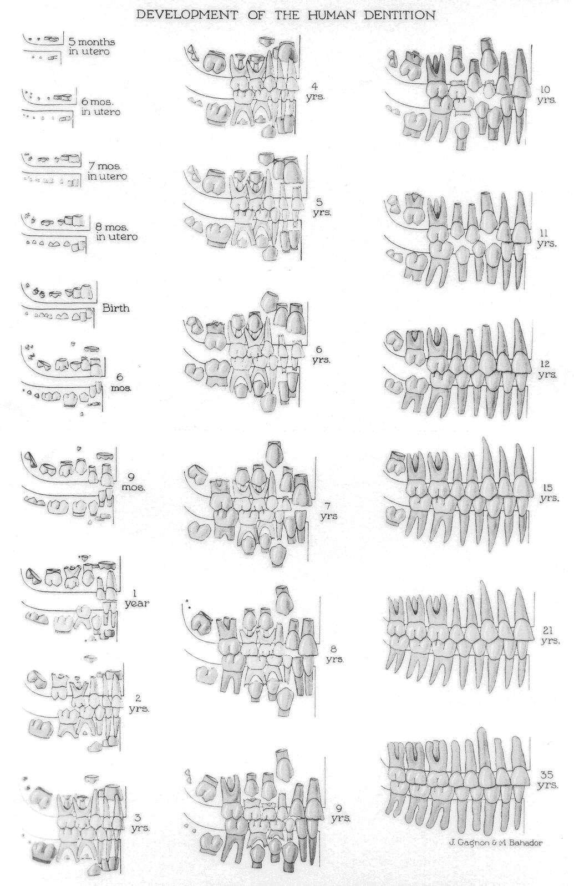

Appendix III
Blenkin and Taylor Dental Development Atlas for Australian Population

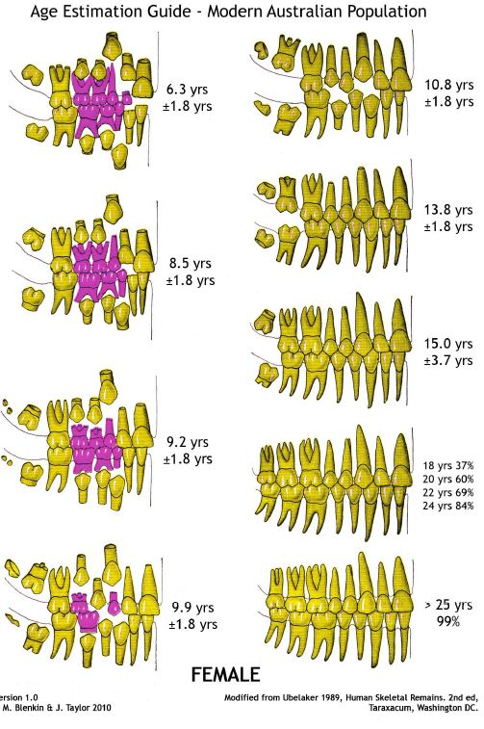

Blenkin and Taylor Dental Development Atlas for Australian Population

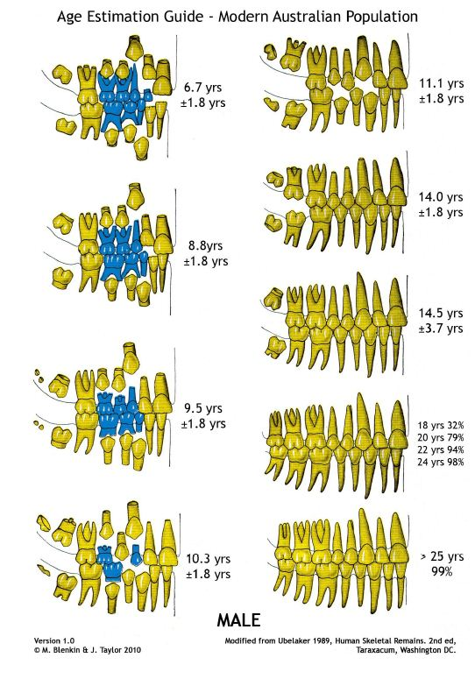

Appendix IV
Sakher J Al Qahtani Dental Development Atlas

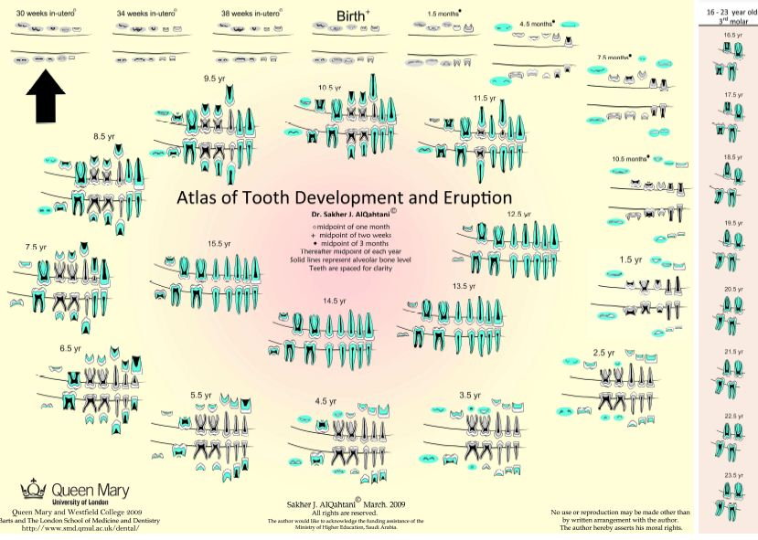

Appendix V

Draft Age Assessment Report

Date

Re: Name
Address

Dear Sir,
At the request of …….Name....…from,…….Organisation..…….., and with written consent from.…Name..….and his legal representative, I arranged a referral for..…….Name…....to have an OrthoPantomoGraph (OPG) and/or Hand/Wrist radiograph to be taken at …….Radiography Department…… on Date

The radiographic images taken were forwarded to my office on the ………Date……………
As background information, the human dentition develops from a process of calcification of embryonic membranous tissue, commonly called ‘tooth germs’. Calcification of the tissue commences prior to birth and is complete in early adult life with the calcification of the root apex of the third permanent (adult) molar tooth - (wisdom tooth).
The OPG radiograph is viewed to:
- evaluate the dental health status of the dentition; a complete clinical oral examination is required to confirm the status of the oral health of the client
- assess the age of the client
The chronological age assessment is determined by comparing the stages of calcification of all teeth and ‘tooth germs’ present on the OPG image with relevant published data from individuals of known age (list attached). The chronological age assessment is expressed as an age range, with confidence intervals.
I forwarded the images to Specialist Forensic colleagues ………………..Insert Names …………………………for their review and comment.

An analysis of the teeth and bone images viewed showed… Unremarkable/Revealed anomalies ……….
Note: All abnormal findings are to be reported and recommendations for further investigation must be made. Any follow-up treatment would be the responsibility of the client who had the OPG taken to arrange.

Evaluating the status of the teeth present with published data on age assessment (as per the list attached) we assess the age of ……..…Name………… at the date the radiographs were taken to be ………… with a range of …+/-…… months.

If additional information is required please contact myself on the above address or by phone
Yours sincerely,

Dr ………………Name………………..
…………………….Title……………
…………………Position

Attached:
Reference list
Reviewers’ Addresses

Appendix VI
Radiation dosage table

